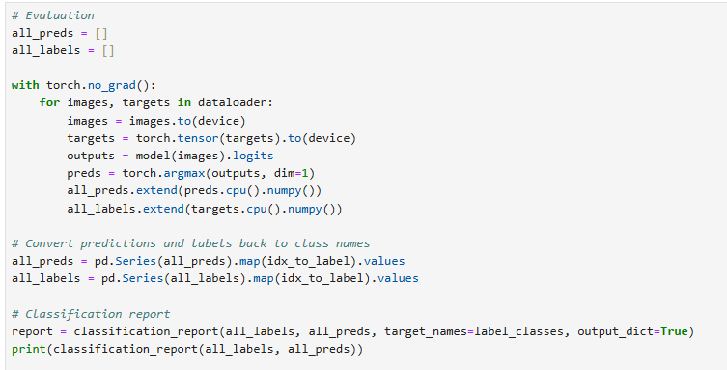

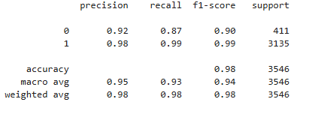

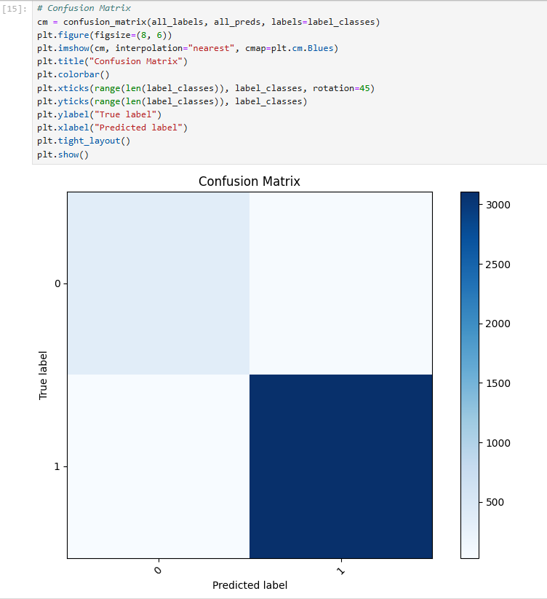

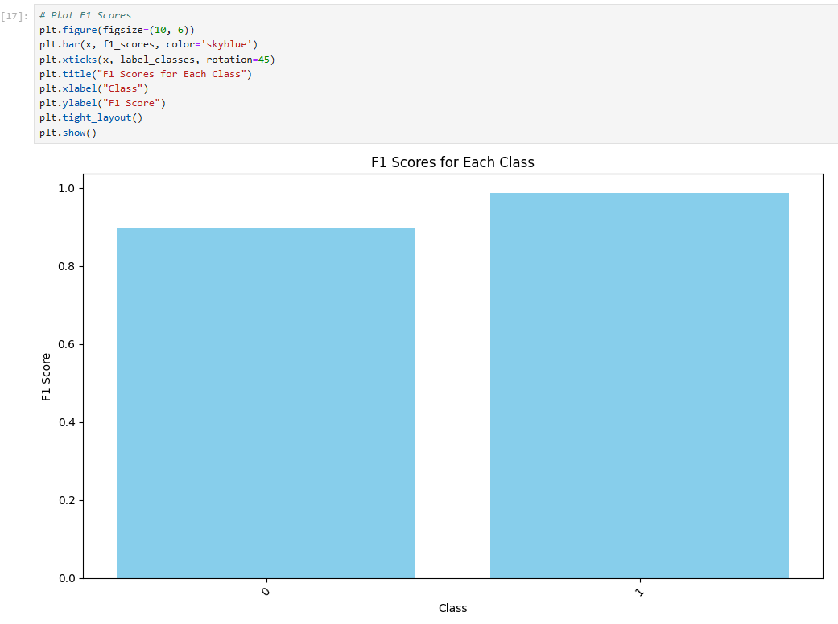

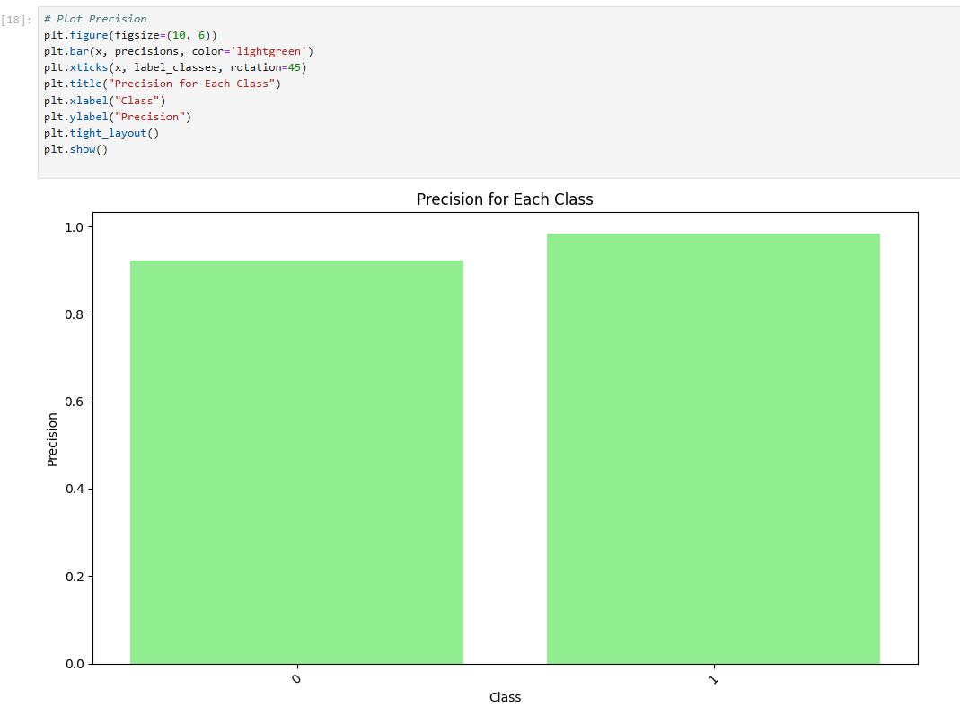

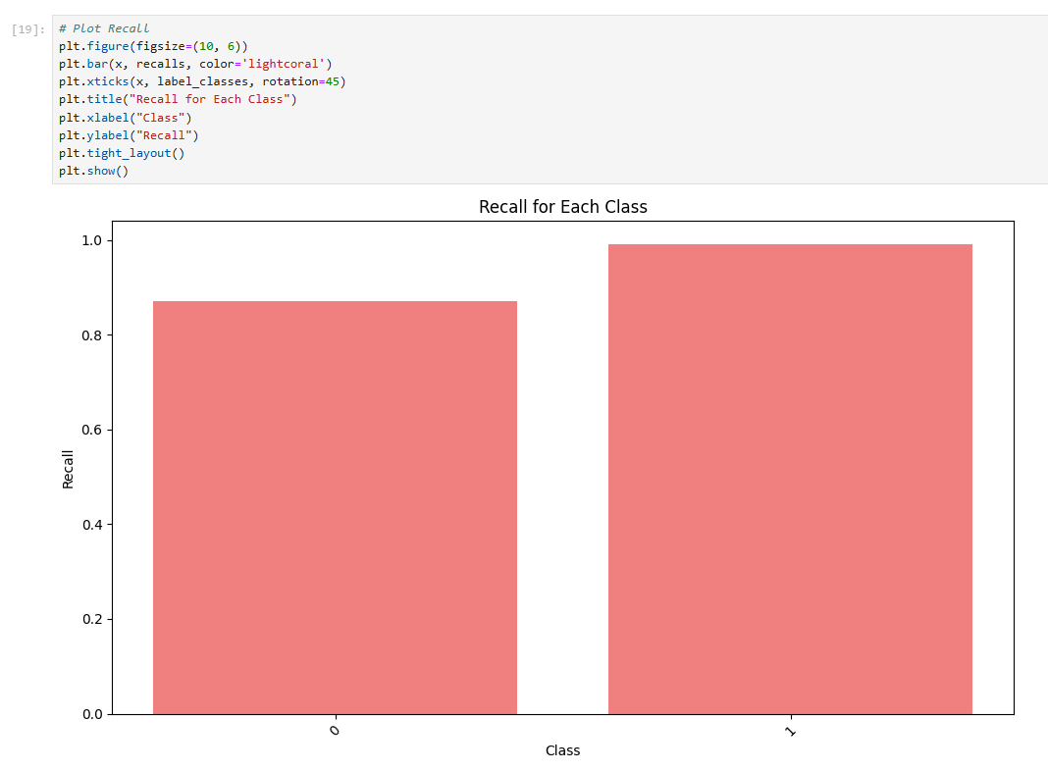

ViT

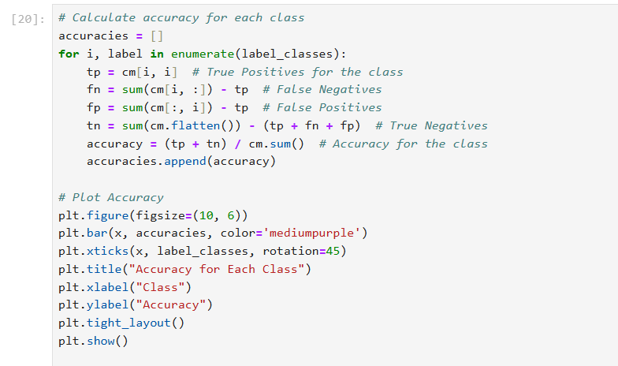

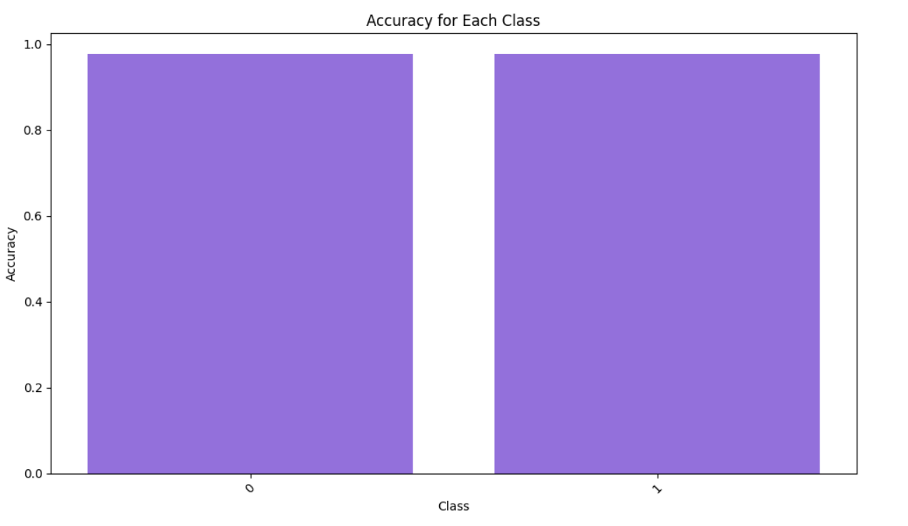

Yolo

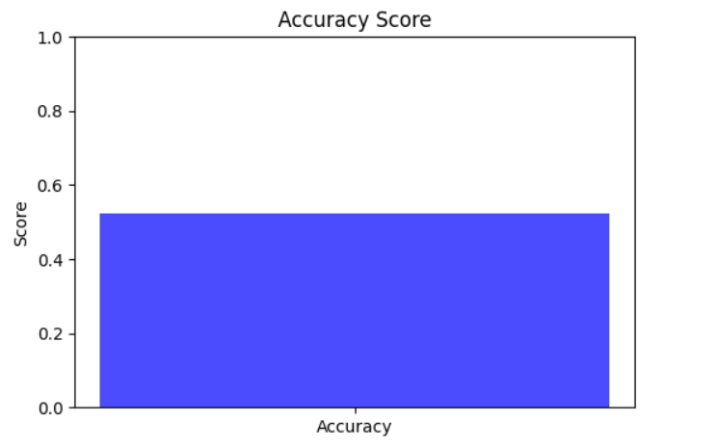

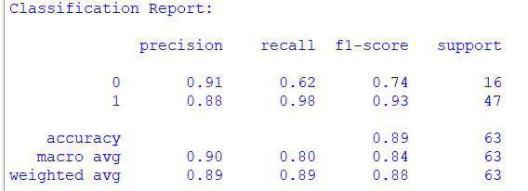

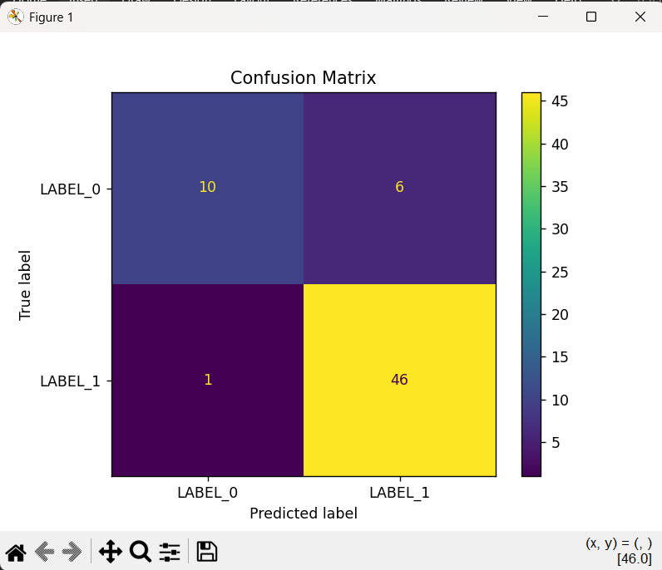

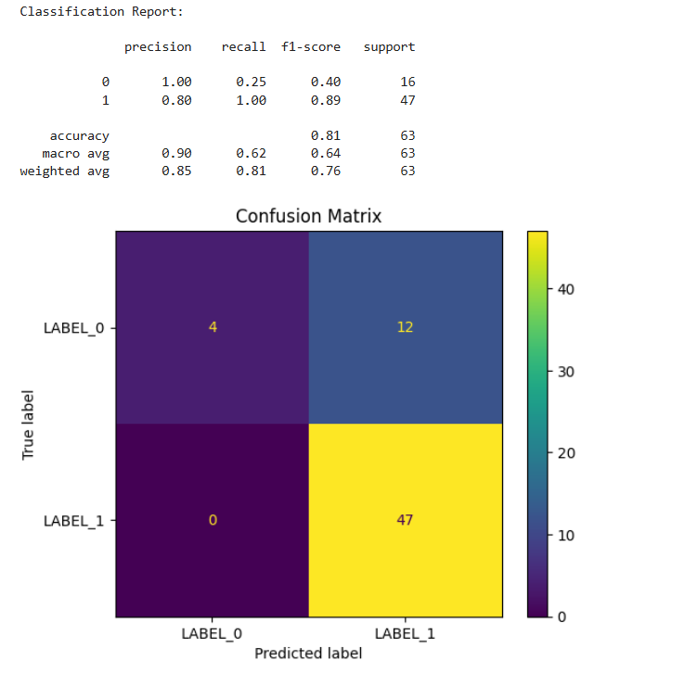

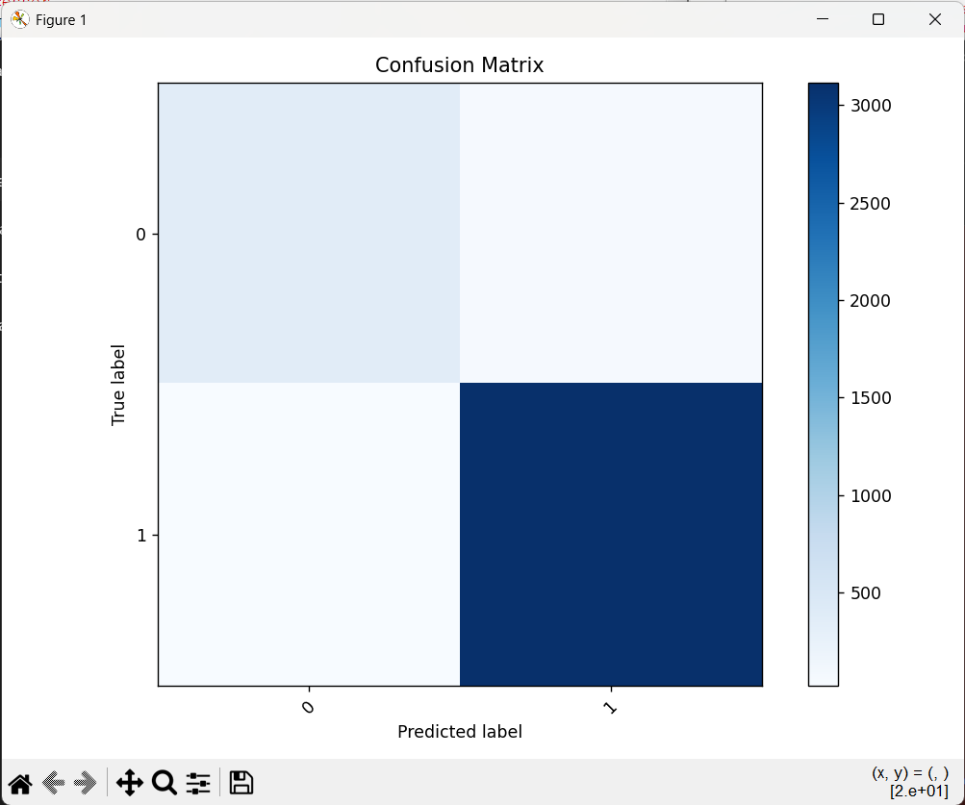

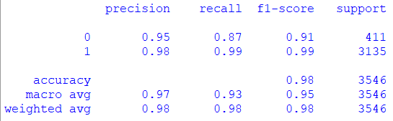

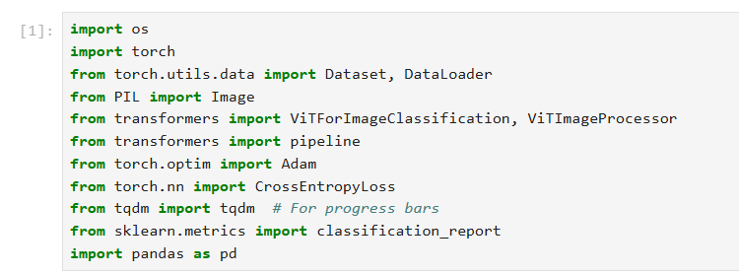

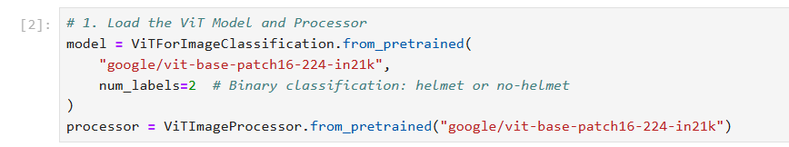

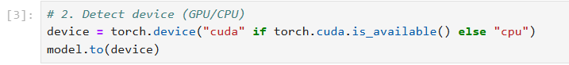

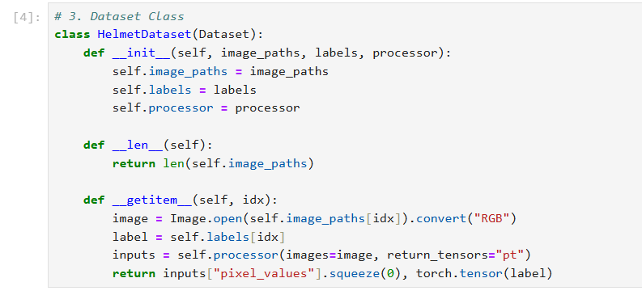

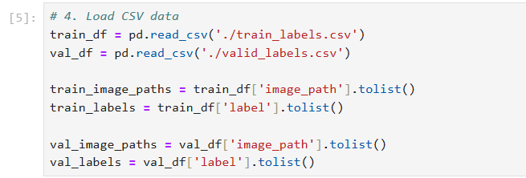

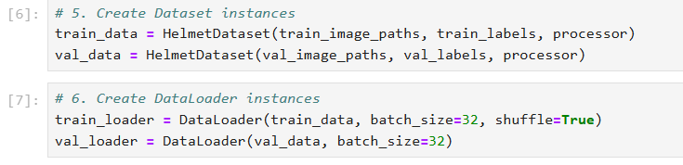

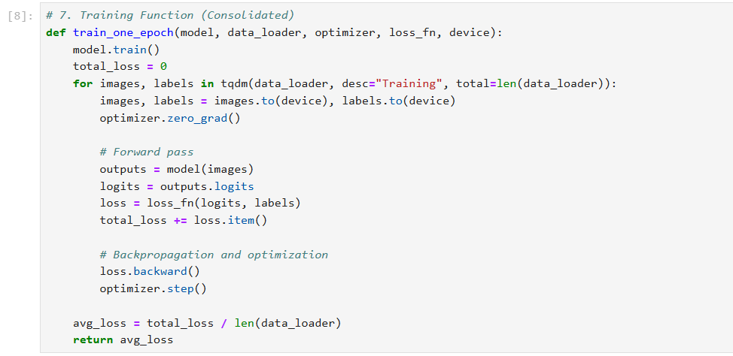

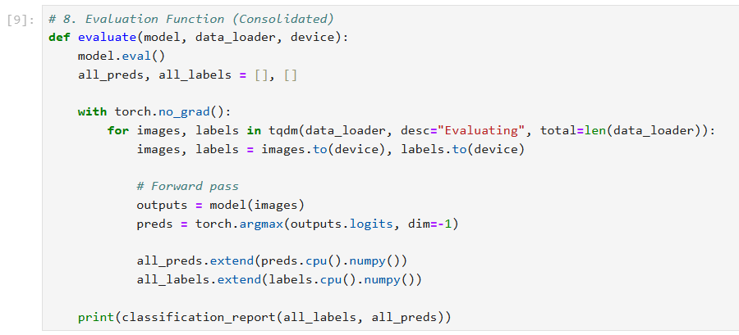

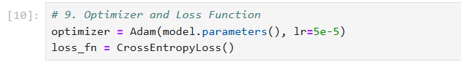

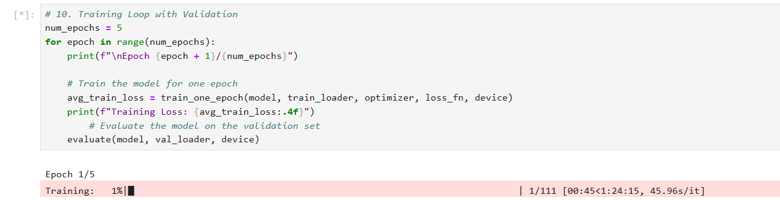

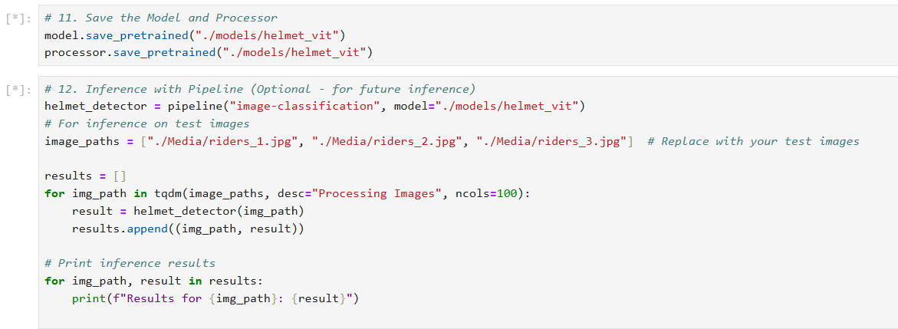

Img

Existing system

Code

import cv2 # type: ignore

import math

import cvzone # type: ignore

from ultralytics import YOLO # type: ignore

# Load YOLO model with custom weights

yolo_model = YOLO("Weights/best.pt")

# Define class names

class_labels = ['With Helmet', 'Without Helmet']

# Load the image

image_path = "Media/riders_1.jpg"

img = cv2.imread(image_path)

# Perform object detection

results = yolo_model(img)

# Loop through the detections and draw bounding boxes

for r in results:

boxes = r.boxes

for box in boxes:

x1, y1, x2, y2 = box.xyxy[0]

x1, y1, x2, y2 = int(x1), int(y1), int(x2), int(y2)

w, h = x2 - x1, y2 - y1

cvzone.cornerRect(img, (x1, y1, w, h))

conf = math.ceil((box.conf[0] * 100)) / 100

cls = int(box.cls[0])

label = f"{class_labels[cls]} {conf:.2f}"

cv2.putText(img, label, (x1, y1 - 10), cv2.FONT_HERSHEY_SIMPLEX, 0.5, (0, 255, 0), 2)

# Display the image with detections

cv2.imshow("Image", img)

# Close window when 'q' button is pressed

while True:

if cv2.waitKey(1) & 0xFF == ord('q'):

break

cv2.destroyAllWindows()

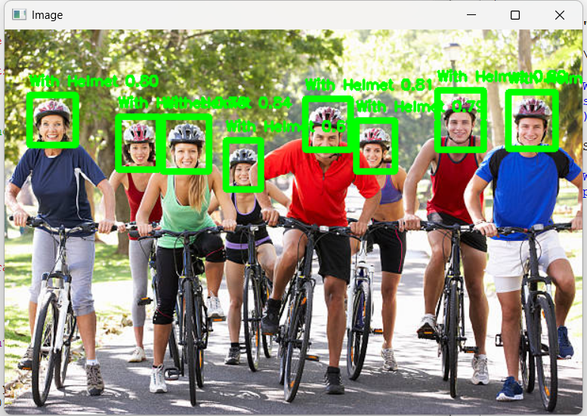

Proposed sys

import cv2

import torch

from transformers import ViTImageProcessor, ViTForImageClassification

import cvzone

from mtcnn import MTCNN

import numpy as np

# Initialize MTCNN for face detection

mtcnn = MTCNN()

# Initialize Vision Transformer (ViT) model and image processor

model_name = "./models/helmet_vit" # Replace with a custom-trained model for helmets

processor = ViTImageProcessor.from_pretrained(model_name)

model = ViTForImageClassification.from_pretrained(model_name)

# Load and preprocess the image

#"Media/riders_5.jpg"

image_path = "Media/riders_3.jpg" # Replace with your image path

img = cv2.imread(image_path)

img_rgb = cv2.cvtColor(img, cv2.COLOR_BGR2RGB)

# Detect faces with MTCNN

mtcnn_detections = mtcnn.detect_faces(img)

# Prepare detections

all_detections = []

for detection in mtcnn_detections:

x, y, w, h = map(int, detection['box']) # Extract bounding box

padding = 20 # Add padding for better helmet detection

x = max(0, x - padding)

y = max(0, y - padding)

w += padding * 2

h += padding * 2

all_detections.append((x, y, w, h))

# Process all detections (none are ignored)

if all_detections:

cropped_images = [cv2.resize(img_rgb[y:y+h, x:x+w], (224, 224)) for x, y, w, h in all_detections]

inputs = processor(images=cropped_images, return_tensors="pt")

with torch.no_grad():

logits = model(**inputs).logits

probabilities = torch.nn.functional.softmax(logits, dim=-1)

# Annotate results for each detection

for (x, y, w, h), prob in zip(all_detections, probabilities):

predicted_class = torch.argmax(prob).item()

confidence = prob[predicted_class].item()

if predicted_class == 1: # Helmet

label = "Helmet"

color = (0, 255, 0) # Green for Helmet

else: # No Helmet

label = "No Helmet"

color = (0, 0, 255) # Red for No Helmet

# Draw bounding box and label

cvzone.cornerRect(img, (x, y, w, h), l=10, rt=2, colorR=color)

cv2.putText(

img,

f"{label} ({confidence:.2f})",

(x, y - 10),

cv2.FONT_HERSHEY_SIMPLEX,

0.6,

color,

2

)

else:

print("No detections found.")

# Display the image with detections

cv2.imshow("Helmet Detection", img)

cv2.waitKey(0)

cv2.destroyAllWindows()

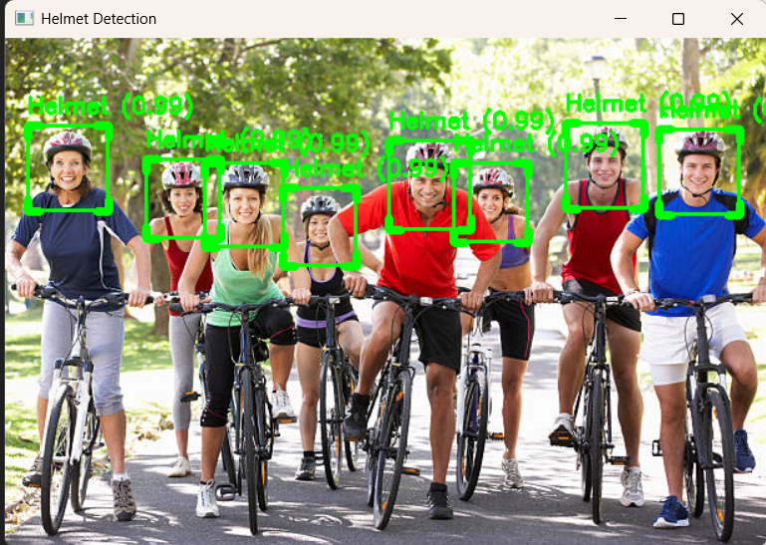

Vid

Existing

import cv2

import math

import cvzone

from ultralytics import YOLO

import os

# Initialize video capture

video_path = "Media/sample.mp4"

if not os.path.exists(video_path):

raise FileNotFoundError(f"Video file '{video_path}' not found.")

cap = cv2.VideoCapture(video_path)

# Load YOLO model with custom weights

weights_path = "Weights/best5.pt"

if not os.path.exists(weights_path):

raise FileNotFoundError(f"Model weights file '{weights_path}' not found.")

model = YOLO(weights_path)

# Define class names

classNames = ['With Helmet', 'Without Helmet']

frame = 0

while True:

success, img = cap.read()

if not success:

print("End of video or error reading frame.")

break

# YOLO model inference

results = model(img, stream=True)

for r in results:

boxes = r.boxes

for box in boxes:

x1, y1, x2, y2 = box.xyxy[0]

x1, y1, x2, y2 = int(x1), int(y1), int(x2), int(y2)

# Draw bounding box

w, h = x2 - x1, y2 - y1

cvzone.cornerRect(img, (x1, y1, w, h))

# Display confidence and class

conf = math.ceil((box.conf[0] * 100)) / 100

cls = int(box.cls[0])

cvzone.putTextRect(img, f'{classNames[cls]} {conf}', (max(0, x1), max(35, y1)), scale=1, thickness=1)

# Display frame

frame += 1

print(f"Processed frame: {frame}")

cv2.imshow("Image", img)

if cv2.waitKey(1) & 0xFF == ord('q'):

break

# Release resources

cap.release()

cv2.destroyAllWindows()

